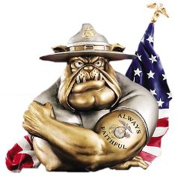

Monthly Newsletter
Corporal Johnny A. Williamson Detachment #1165

Marine Corps League - Asheboro, N.C.
April 2017 – June 2017
Our Next MCL Meeting Date: Tuesday April 18th

Detachment Officers 2016-2017

Commandant ---------------------------- Danny R. Wood
Phone: 336-672-2865
Cell: 336-301-2299
e-mail: dwood@dmp-inc.com
Senior Vice Commandant----------- Harvey L. Allred
Phone: 336-629-8132
Cell: 336-460-0421
e-mail: hallred56@triad.rr.com
Jr. Vice Commandant--Charles Zimmerman (Chuck)
Phone: 336-431-8964
e-mail: chuckieboy90@yahoo.com
Judge Advocate ------------Wilbert Waldridge (Wally)
Phone: 336-622-4074
e-mail: wallyman@rtelco.net
Adjutant ---------------------------- William Petty (Bill)
Phone: 336-889-7817
Cell: 336-953-3537
e-mail : tag1195@yahoo.com
Paymaster ------------------------ D. Filmore York (Fil)
Phone: 336-622-2121
Cell: 336-212-0223
e-mail: fyork@triad.rr.com
Chaplain -----------------------James R. Williams (Ron)
Phone: 336-625-9898
Cell: 336-963-3965
e-mail: nchp611@aol.com

Sergeant at Arms ----------------- Gary Q. Caviness
Phone: 336-879-3132
e-mail: garyandphyllis@rtmc.net
Historian -------------------------------- H. Carlton Cheek
Phone: 336-629-1049
e-mail : onehoursherry@triad.rr.com
Photographer --------------------------------- Steve Sugg
Phone: 336-879-4017
e-mail: sasugg@rtmc.net
Past Commandant -------------------- Harvey L. Allred
2009-2012 & 2013-2016

The Chaplains Office
Keep all who are in harms way in your thoughts and prayers. If any member knows of a member who is sick or hospitalized, please notify the Detachment Chaplain Ron Williams. or one of the Detachment Officers as soon as possible. Semper Fidelis / God Bless

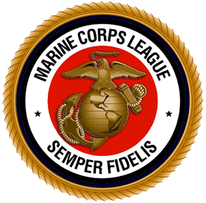

MCL Meeting : If You Come We Will Feed You! Between 1815 -1900 Dinner will be served at our monthly meetings. The Meal for April will be a surprise meal provided by Our Detachment. Come join us for the camaraderie with your fellow Marines. The Meeting will begin around 1900 and conclude NLT 2000.
April 2017
Detachment Meeting – Tuesday 18th
Social Hour / Dinner – 1800 Meeting 1900
American Legion Post 45
Nominations/Elections for 2017/2018 Staff Officers
Annual Spring Golf Tournament – Saturday 22nd
Breakfast 0800-0900 Tournament Begins at 0900
Asheboro Country Club, off Hwy 64 West
May 2017
Family Day Picnic Saturday May 6th
Lake Lucas Shelter at Lake Lucas 1100-1400
Covered Dish Lunch at 1200 Noon
Detachment Meeting – Tuesday 16th
Social Hour / Dinner – 1800 Meeting 1900
American Legion Post 45
Installation of 2017/2018 Staff Officers
Flag Placement – Saturday 27th
Oaklawn Cemetery 0900 Until
Come Join Us We Could Use Your Help !!
The Downtown Asheboro Memorial Day Service is Monday May 29th at 1600 out front of the Old Court House at the Veteran’s Memorial.
Memorial Day is – Monday 29th
Retrieve Flags on Tuesday 30th @ 10:00am
June 2017
Detachment Meeting – Tuesday 20th
Social Hour / Dinner – 1800 Meeting 1900
American Legion Post 45

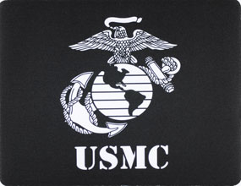
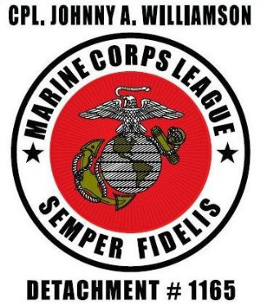
Members & Guest in Attendance on March 21st.
Bill Husband Lucky Luckado
Bill Petty Mitchell Davis
Carl Corning Pete Stephens
Chuck Zimmerman Raymond Hoover
Craig Wolfe Ron Williams
Danny Wood Russell Demedina
Filmore York Steve Sugg
Harvey Allred Ty Hall
Wally Waldridge
Associate Members Elizabeth Nault, Kayte Wigginton
and Zoe Faircloth
Our Evening Guest
Jesse Jones

Thanks to Everyone That Attended

This is your Newsletter, If there is anything You would like to add for next month let me know ASAP !!

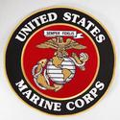

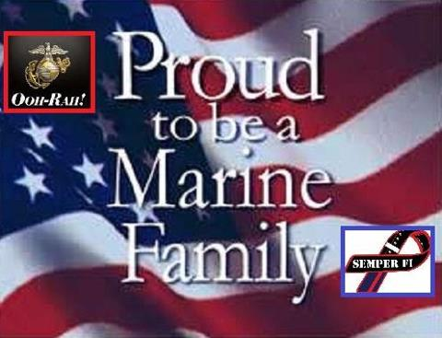

Honor Courage and Commitment

In Memory of
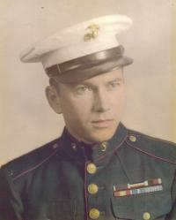
Jimmy H. McInnis
January 17, 1929 – April 28, 2008

ASHEBORO - Jimmy Harold McInnis, age 79, of 731 West Kivett Street, Apt.26A, Asheboro died Monday, April 28, 2008 at Randolph Health and Rehabilitation, Asheboro.
Mr. McInnis was born January 17, 1929 the son of Clarence and Pearl McInnis.
Mr. McInnis was a native of Moore County and was a Marine in the Korean Conflict where he was awarded a Purple Heart. Mr. McInnis was a member of American Legion Post 45 in Asheboro and Lions Club of Randleman where he was also Precinct Chairman. He owned Jim's Barber Shop and Riverside Motors in Randleman and was of the Baptist faith. Mr. McInnis is preceded in death by his wife, Barbara McInnis.
He is survived by his daughter Jennifer and her husband, Thomas Garren, of Asheboro; grand-daughter, Hannah Garren of Asheboro.
The family will receive friends Wednesday, April 30, 2008 from 6:00 - 8:00 PM at Pugh Funeral Home, 600 South Main Street, Randleman, NC and other times at his home. The funeral will be Thursday, May 1, 2008 at 2:00 PM at Pugh Funeral Home Chapel, 600 South Main Street, Randleman with Dr. Richard Crider officiating. Burial will follow at Randolph Memorial Park, Asheboro.
_________________________________________
Congratulations This Month!!
Birthday’s and Wedding Anniversary’s
Jed Frye 2nd Larry & Susan Lewallen 16th
Bill Husband 23rd Bill & Phyllis Petty 22nd

In Memory of
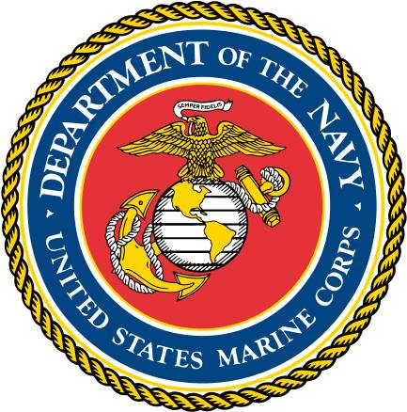
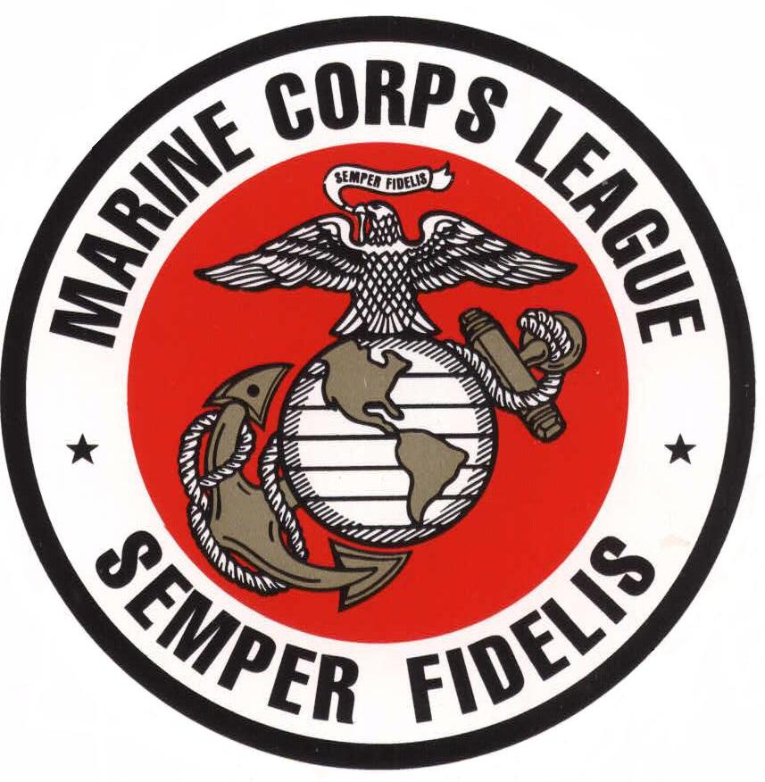
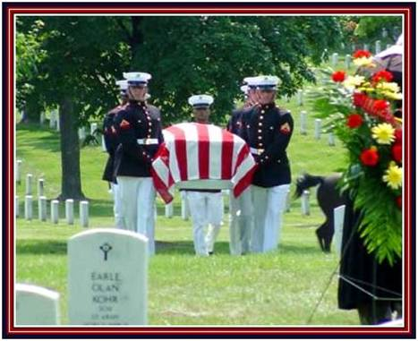
Kenneth Wayne Bickell
June 24, 1950 - April 14, 2013

Kenneth Wayne Bickell, of Del City Oklahoma, formerly Randleman, North Carolina passed away on April 14th after a valiant hard-fought battle with cancer. Ken was born in Orange California on June 24, 1950. He graduated from Del City High School in 1968. He was a member of Demolays and Civil Air Patrol during high school. Ken served in the United States Marine Corps for 16 years, including three tours of duty in Vietnam. He was honorably discharged in 1984. Kenneth completed an Associate's Degree and worked as an aircraft frame repair supervisor for Timco in Greensboro, NC when he became ill. His passion was search and rescue as a Civil Air Patrol Captain in North Carolina and a Boy Scout volunteer. Ken was the firstborn of Frank and Anna Piercy Bickell of Del City who survive him. Ken was laid to rest April 16, 2013 and is buried in the National Cemetery at Fort Gibson Oklahoma. Ken was a member of the Corporal Johnny A. Williamson Detachment, Marine Corps League since February 1, 2004
On Behalf of the President of the United States the Commandant of the Marine Corps and the Corporal Johnny A. Williamson Detachment # 1165, Marine Corps League.
Thank You for your Many Years of Service to our Country and Corps.

Semper Fidelis

Staff Elections for 2017 / 2018
At our April 18th meeting we will take nominations for the new staff for the 2017-2018 year. Members interested in any of the open positions contact a member of the Nominating Committee –
(Chairman) Carlton Cheek 629-1049
Danny Wood 672-2865 or Steve Sugg 879-4017 Openings are: Commandant, Senior Vice Commandant,
Junior Vice Commandant, Judge Advocate. Elections will be held following nominations at our April 18th meeting. Installation of Officers will be held at our May 16th meeting.

Elected Officers
The officers to be elected by the Detachment shall be the Commandant, Senior Vice Commandant, Junior Vice Commandant, Judge Advocate. Nominations and elections will be held annually at regular scheduled meetings. Installation of officers will be held as soon as practicable and not later than thirty (30) days after the election.

Detachment Staff
The Detachment Staff shall be constituted of the elected officers and the outgoing Detachment Commandant or Past-Commandant.

Terms of Office
Detachment Officers are elected for the term of one (1) year and may succeed themselves if reelected by the membership. Elected Officers shall be limited to a total of three (3) consecutive years in any elected office. All appointed Officers are appointed for a period of one (1) year and may succeed themselves at the pleasure of the Commandant Elect and the approval/consent of the Detachment Staff.

COMMANDANT – It shall be the duty of the Commandant to preside at all meetings, to observe and enforce the observance of the provisions of the constitution and by-laws, to make and promulgate such orders as may be necessary for the proper administration of the affairs of the Detachment, to countersign checks for disbursement made by the Detachment and to perform such other duties as provide for in the constitution and by-laws of this Detachment to his duty elected and qualified successor.

SENIOR VICE-COMMANDANT – It shall be the duty of the Senior Vice-Commandant to perform such duties as may be assigned to him by the Detachment Commandant, and in the event a vacancy occurs in the office of the Commandant, be prepared to assume that position. He may also have the authority to countersign checks. He shall be prepared to surrender all books, records and other property of the Detachment to his duly elected and qualifies successor.

JUNIOR VICE-COMMANDANT – It shall be the duty of the Junior Vice-Commandant to chair membership and member retention programs. He shall assist the Sergeant-at-Arms in greeting members and guests. Presides in the absence of both the Commandant and Senior Vice-Commandant. He shall be prepared to surrender all books, records and other property of the Detachment to his duly elected and qualified successor.

JUDGE ADVOCATE – It shall be the duty of the Judge Advocate to act as legal counsel for the Detachment and to render opinions on all questions of law that may arise concerning any of the by-laws of the Detachment. He shall be prepared to surrender all books, records and other property of the Detachment to his duly elected and qualified successor.

ADJUTANT – It shall be the duty of the Adjutant to keep proper and necessary records of all business of the Detachment. He shall keep minutes of the meeting and perform such duties as are usually assigned to a recording secretary. He shall be prepared to surrender all books, records and other property of the Detachment to his duly appointed successor.

PAYMASTER – It shall be the duty of the Paymaster to hold all moneys and securities of the Detachment, to disburse moneys which have been approved by the Detachment, to keep a correct record of all financial transactions, to deposit all moneys and securities in the financial institution designated by the Detachment and in the name of the Detachment countersign all checks of the Detachment. He shall be guided in the performances of his duties by close adherence to the preceding paragraph 30.40 FINANCES of the Constitution and by-laws of the Detachment. He shall be prepared to surrender all books, records and other property of the Detachment to his duly appointed successor.

*Appointed Positions by The Detachment Commandant are Adjutant, Paymaster, Sgt-at-Arms & Chaplain*

Members interested in any of the open positions should contact a member of the Nominating Committee As Soon As Possible to have your name placed on the ballet. (Chairman) Carlton Cheek 629-1049, Danny Wood 672-2865 or Steve Sugg 879-4017

Our 13th Annual Marine Corps League
Spring Golf Tournament Open to All Golfers Military & Civilian

Saturday April 22, 2017
Rain Date: April 29th


The Corporal Johnny A. Williamson Detachment #1165
Marine Corps League, Asheboro N.C.
-------------------------------------------------------------------------------------------------
Tournament Location
Asheboro Country Club
5105 Old Lexington Road Asheboro, N.C. 27204
Just off Hwy 64 West of Asheboro
Captains Choice
Entry Fee: Pre Team Registration by April 20th $40.00 Per Golfer $50.00 on day of Tournament (Donations Tax Deductible)
Mulligan’s For Sale on Day of Tournament ( Players are Limited to 2 Mulligan’s ) for $5.00 Each
Proceeds supporting our Marine Corps League, our Members in need and the Marines/Sailors in the Community
Prizes to be awarded 1st Place Team $400.00 and each Player a Free Round of Golf
2nd Place $200.00 and 3rd Place $100.00

Win a round of golf for two on Hole #17 Closest to the Pin and a round of golf for two on Hole #18 Longest Drive
Each Player Receives a Coupon for a Golf Club
We will also have a 50/50 Raffle before the Tournament Begins
From 8:00am - 9:00am
*Team Registration *
Breakfast will be served 8:00am – 9:00am, Sausage Egg & Cheese Sandwich & Fresh Fruit
9:00am Shotgun Start
Contact: * Asheboro Country Club Pro Shop* 336-685-3507 or
Contact Our Marine Corps League Chairman Harvey Allred for more Details
Contact Harvey @ Home 336-629-8132 or Cell 336-460-0421
e-mail hallred56@triad.rr.com
1702 Southwood Drive, Asheboro N.C. 27205

Golf Sponsors
We are also looking for local Businesses that would like to sponsor a hole at our Golf Tournament.
The (Donation) is $50.00 (Tax Deductible). A sign with your business name will be displayed on one
of the eighteen holes. Cut off date in order to have your sign made is 1200 noon April 18, 2017
Make your check payable to:
Marine Corps League
Thank You in Advance for Your Support All participants agree to hold the Corporal Johnny A. Williamson Detachment, Marine Corps League, the Asheboro Country Club and / or any other agency or individual acting on it’s behalf, harmless for any loss or damage to / of funds, property or injury as a result of their participation in this event
“Once a Marine, Always a Marine”

Information Needed for Each Team
$40.00 Per Player Per Team Prior to April 20th $160.00
$50.00 Per Player Per Team on Day of Tournament $200.00

Team Players Names

Captain __________________________________________
Print Players Name Above (Phone Number)

__________________________________________________________________________________
Your e-mail Address
_________________________________________________
Print Players Name Above
_________________________________________________
Print Players Name Above
_________________________________________________
Print Players Name Above

_____________________________________________________________
Sponsors Names

Contact Harvey Allred with the Marine Corps League
336-629-8132 Home
336-460-0421 Cell
hallred56@triad.rr.com

Complete this form and send it in with your check ASAP

Make Check Payable to: Marine Corps League

Mail Check to: 1702 Southwood Drive
Asheboro, N.C. 27205-1449
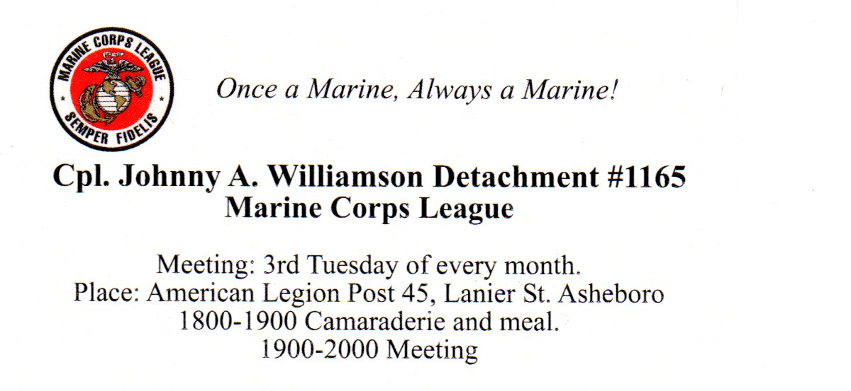

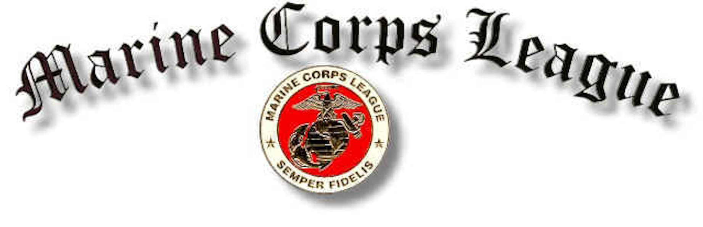
Corporal Johnny A. Williamson Detachment #1165

Marine Corps League Monthly Meeting Held March, 21 2017
At the American Legion Post 45 Asheboro, N.C.

There were a total of 21 in attendance 18 members, 3 associate members and 1 guest.

Commandant, Danny Wood, called the meeting to order at 1900 hours.

Acting Sergeant at Arms Pete Stephens opened the meeting with everyone saying The Pledge of Allegiance while saluting our flag.

Chaplain Ron Williams gave the opening prayer.

Commandant Danny Wood called for Sergeant at Arms to secure quarters.

Sergeant at Arms declared the meeting open for business. Danny asked for the roll call of officers present.

- Senior Vice Commandant – Harvey Allred _ Present
- Junior Vice – Chuck Zimmerman _Present
- Judge Advocate – Wally Waldridge-Present
- Adjutant – Bill Petty _ Present
- Paymaster – Filmore York _Present
- Chaplain – _Ron Williams_ Present
- Sgt-at-Arms – Gary Caviness _ Excused Absent

Introduction of Guests

Our returning guest was Jesse Jones said that he was 43 years old and a Desert Storm veteran. He said that he worked for the Randolph County Schools doing heating and air and was invited by Ty Hall.

Application for membership

None

Members or Family Members Sick or in Distress.

Danny said that he got an e-mail from Larry Beane and his wife was recovering from surgery and he needed to stay with her. He also mentioned Ray Moore was in Clapp's nursing home and if anyone wanted to visit him now was the time to go.
Danny said that Gary Caviness was in High Point Regional Hospital with blood clots in his lungs and hopefully would be released soon.
Danny said that he had just learned that Tom Cole’s son had died, but he didn’t know any details yet.
Ron Williams told about his son Air Force Major Jason Williams, stationed Eglin Air Force base in Florida that two weeks ago he was diagnosed type II diabetic. He said that he is taking insulin 3 times a day and now has it under control. He said that it will not affect his career in the Air Force.
Wally said that his wife Eva is doing much better now, her cancer count used to be four thousand, now was below two hundred.

Report of Officers
Harvey passed around to everybody pictures of the bricks at the field of Honor in Kernersville and asked for each member to sign their name to their choice, he said that the selection was to be submitted by the end of March.
Harvey said that he spoke with Bill Knight secretary in charge of the bricks, and the nine new bricks for our past members would be placed with our league brick. Harvey asked that if Ray Moore pasted before he turned in the selection on the style of brick could we add his name for brick number ten. He asked for a vote and it was approved.

Announcements for the good of the League

Chuck Zimmerman said that he had talked to Lucky about an open house to recruit new members.
Chuck said two years ago that they found a spot on his lungs and after several years the spot has not changed.
Bill Petty reported that out of 55 of last year’s golf sponsors only 15 have been contacted so far, but we have 3 new sponsors this year so far.
Harvey spoke about the golf tournament sponsors and asked everybody for their help with old sponsors and getting new ones and also getting teams to commit.

Harvey said that lucky had talked to Bill Beeson and his daughter Jenny had agreed to make any new sign for any new sponsor.
Kayte said that a colleague of hers would like to be a sponsor, but did not want her name on any sign, Harvey said no problem.
Harvey said that Rankin Brown who works for K&W told him his Vice President saw the flyer for our golf tournament and he offered cash donation, gift cards or meals for golfers and Harvey said he thought maybe something for all the golfers, but they haven’t decided for sure what they would do yet.
Harvey mentioned our family day picnic at Lake Lucas on May, 6 and flag placement at Oaklawn on Saturday May 27th and the Memorial Day Service on Memorial Day Monday the 29th down town Asheboro.
Flag retrieval will be Tuesday the 30th at 10:00. Harvey asked to take out any flags that are unserviceable.
Chuck asked if we were able to get any better quality of the Marine Flag and Harvey said that so far nobody yet has anything any better quality.
Harvey said that our next meeting on April 18th is when we will have our nominations for new officers and installation of new officers on May 16th.
Harvey said that our DoNC Senior Vice Commandant Jeffrey Jones attended our bowling fund raiser and he asked him if he would conduct the installation of new officers and he said that he would.
Harvey asked if anyone would like to serve as one of the new officers to contact the nomination committee.
Steve asked Harvey if he had checked with Sgt Grit on any Marine flags and he said that he had only checked with flag companies
Craig Wolfe said that he was now a member of the Randolph County Honor Guard and that they try to attend every Veteran’s funeral between Raleigh and Winston-Salem. They have 3 vans with 8 or 9 on each mission. He said if anyone wanted to become a member to check with him.
Lucky said that some had asked him about pound 327 and they finally had a meeting. He said if anyone wanted to join to let him know.
Lucky said that the Memorial Day celebration is sponsored by the Randolph County Veterans Council on Monday May 30th at 1600 in Asheboro.

Zoe said that David Camp informed her that the Veterans appreciation night at the Copperheads game will be on Saturday June 3rd Veteran’s Appreciation will start at 6:30. Veterans and spouses are free and should arrive around 6:00.
Lucky wanted to remind everybody Operation Remembrance where the Veterans Council will supply flags to any church for placement on veterans graves.
I told Steve that I just checked Sgt Grit on line and found the same flag that we were using and it was $4.99 and that I would ask about discount for quantities.

Danny closed the meeting with the singing of the 1st verse of the Marine's Hymn.

Commandant asked Sergeant at Arms to lead us in the hand salute of our colors.

Chaplain Ron Williams gave the closing prayer.

Senior Vice Commandant Harvey Allred preformed his last duty of the day.

Acting Sergeant at Arms Pete Stephens declared this meeting closed until our next meeting on April 18, 2017

50/50 winner was Wally Waldridge. He donated all $45 to the league.

Respectfully submitted this day of April 18, 2017

Adjutant______________________________________________
Bill Petty

Accepted by Commandant________________________________
Danny Wood



